Discipline/behavior is added using the Behavior Management Tool shown below. The Behavior Management Tool allows users with the appropriate tool rights to manage existing behavior as well as enter new behavior incidents.

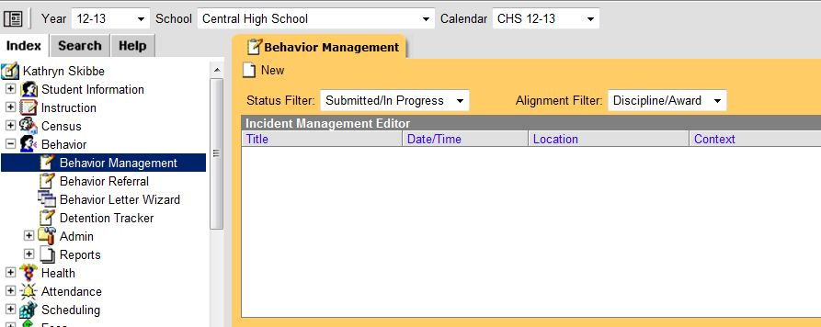

Note: If you need to “update” existing Behavior Information on a student, you can go to the Behavior Tab on a student, navigate to the behavior incident that needs to be modified and then click on the Incident highlighted in blue. Click on the Incident ID. This will bring you into the Behavior Management Tool where you can make changes.

Add Behavior Incident

The first thing that must be added when entering “behavior” is the incident. An incident is a group of behavior events linked by time and proximity. Events do not have to be related nor have the same participants to be grouped together in an incident. In this way, incident reporting is similar to a police report - a record of occurrences at a specific time and place. Let’s use this example:

Playground Incident
During recess at an elementary school, a fight breaks out between two students. A teacher breaks up the fight and one of the students calls the teacher an inappropriate name. While the fight is happening, another student is caught throwing rocks at the students involved in the fight. This occurrence would be considered a single incident with multiple events (the fight, disrespect towards staff, and throwing objects) and multiple participants (fighting students, student throwing objects).

First we enter the Behavior Incident. Click on Behavior Management and click New:

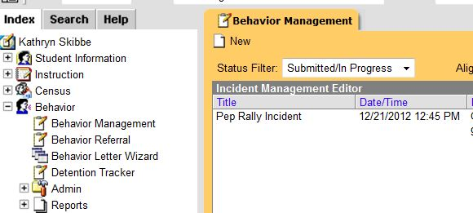

Enter the Incident Detail Information and be sure to SAVE:

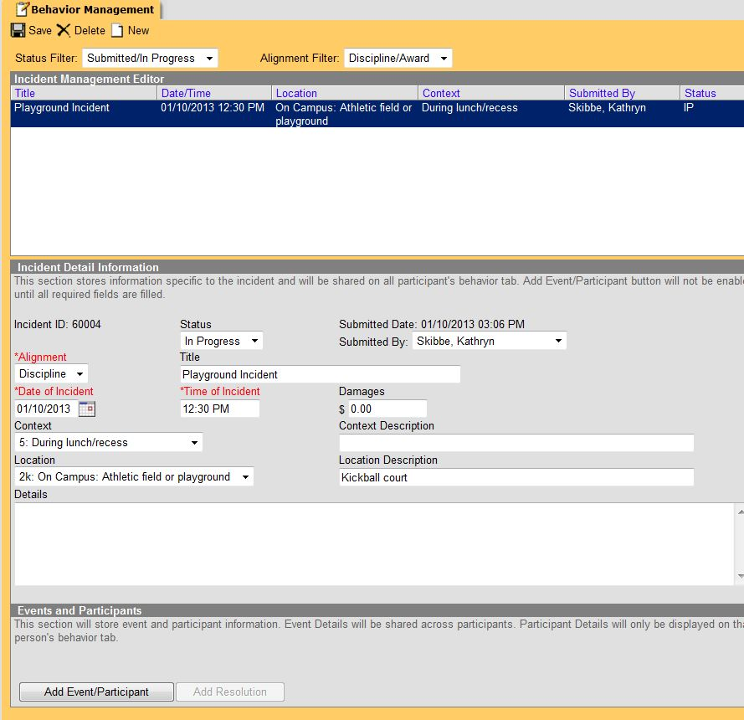

- Incident ID: The unique identification number assigned to the incident once the record is saved. This field cannot be edited.
- Status: The status of the incident as Submitted, In Progress and Complete. Once all keying is complete,
you must update the status to COMPLETE and SAVE.
- Submitted Date: The date the incident record was reported. This field cannot be edited.
- Submitted By: The user who enters the incident.
- Alignment: Indicates if the incident is related to Discipline (negative) or Award (positive). (Parkway currently does not use this tool for Awards.)
- Title: A brief description of the incident. If no title is entered for the incident, the Event Type Name(s) will populate as the incident name.
- Date of Incident: The date the incident takes place. Defaults to the date the incident is created.
- Time of Incident: The time the incident takes place. Defaults to the time the incident is created.
- Damages: The total cost of all damages that occurred as a result of the incident.
- Context: Indication of the setting or time of day the incident took place.
- Context Description: Additional information about the context of the incident.
- Location: Where the incident took place.
- Location Description: Additional information about the location of the incident.
- Details: Any additional information about the incident, including a description of what occurred

Fields in red text and indicated by an asterisk are required and must be entered before the record can be saved. Once general incident information has been established, add Events to describe the individual occurrences and the Participants in each event.

REMINDER
- Incident:
  - In Infinite Campus and in the discipline report created by PARS, the ‘incident’ name will be the first line item, therefore, please be aware of what you name an incident
  - If the incident has more than one event attached to it, name the incident something that describes the most serious offense (fight, drug possession, insubordination, etc.)
  - Do not use student names in the incident name
  - IMPORTANT: schools are responsible for sharing student names for incidents and events with more than one student attached to it – an email with the names attached to an incident must be sent to Christy DeWees – this only applies to out of school suspension.

Add Behavior Events and Participants

Click Add Event/Participant to open the Event/Participant Details editor. Using the Playground Incident, add all the Events that took place and the Participants:

- Fight
- Disrespect Towards Staff
- Throwing Objects

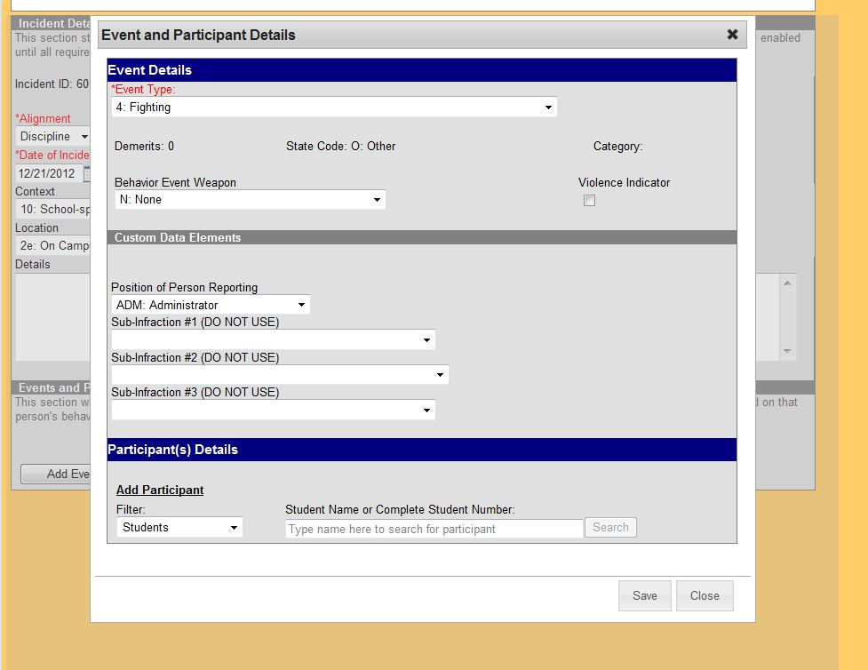

Event Type: The identifying code and name of the event, sorted alphabetically by name. (The number at the beginning of the Event Type is the Parkway Standard number.)
Demerits/Points: Not used.
State Code: The State Event Code the event is mapped to. This information is used to report behavior events to the state. This field automatically displays when the Event Type is chosen.
Category: Not used.
Behavior Event Weapon: If a weapon was used, indicate that here.
Violence Indicator: Not used.
Position of Person Reporting: The position of the person reporting the event.

Once the Event (Fighting) has been entered, the Participants can be entered. Under Participant Details, search for the Students involved in the Fight by entering a few characters of the last name and then the search button. Click the participant’s name to add them to the event. (You can also do searches on All People and Employees.)

These two participants were added and the Participant Detail box opens:
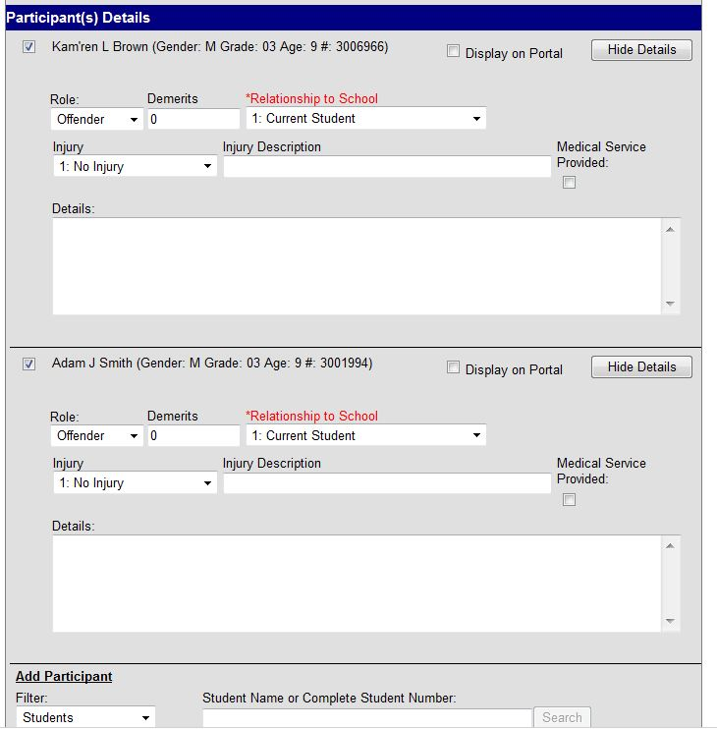

Display on Portal: Not used.
Role: The way in which the individual participated in the event, as an Offender, a Participant, a Victim or a Witness. Change as needed.
Demerits/Points: Not used.
Relationship to School: Indicates the participant's relationship to the school, such as current or former student or staff member, at the time of the event. This field is required.
Injury: Indicates if the participant received an injury as a result of the event. Options are 1: No
Injury, 2: Minor Injury, 3: Major Injury or 4: Serious Bodily Injury.
Injury Description: Additional information about the student's injury.
Medical Service Provided: Indicates if medical service was provided to the individual as a result of the event.
Details: Additional information about the individual's participation in the event.

REMINDER
- Event:
  - Multiple events can be attached to one incident, and different students can be attached to those same events
  - IMPORTANT: if more than one event PER STUDENT is attached to the incident and the same resolution/consequence/suspension is applied to each event, ONLY APPLY the resolution to ONE EVENT (if the same resolution is applied to all the events under one incident, the resolution will be counted multiple times when the data is extracted)
  - Enter location information for each event

- Office of Civil Rights (OCR) data
  - Allegations of bullying/harassment based on: disability, race or gender:
    - You will record this data for allegations only
    - Record any/all allegations you receive if you determine they are based on disability, race or gender
    - Do not attach any student names to the incident/event (after an administrator investigation, if it is determined that the allegation was linked to an actual incident, that is where you will record student/offender information)
    - Regardless if the allegation becomes an actual bullying event or not, the allegation should remain in Infinite Campus and a new incident would be added if it was determined to have happened
    - Bullied/harassed based on disability, race or gender:
    - If there is an allegation which an investigation then determines to be true, there should be two entries (allegation and the bullying/harassing incident)
    - IMPORTANT: If it is determined that bullying/harassment that occurred was based on disability, race or gender, this is the ONLY time in the behavior module you will record victim (if out of school consequences are given for this misconduct, the name of the victim should be shared with Christy DeWees)
CONTINUED ON NEXT PAGE

    - If multiple students are alleged to have been bullied on the basis of race, gender or disability, and it is a single incident, OCR wants us to count just a single incident. Therefore, only one entry should be made even though multiple students were alleged to have been bullied.
You can save at this point and add the other events for Disrespect Towards Staff and Throwing Objects. The participants added for the fight will show up and you can choose them, if they are part of the next event, or add new participants. In this case, Adam Smith was Disrespectful Towards Staff.

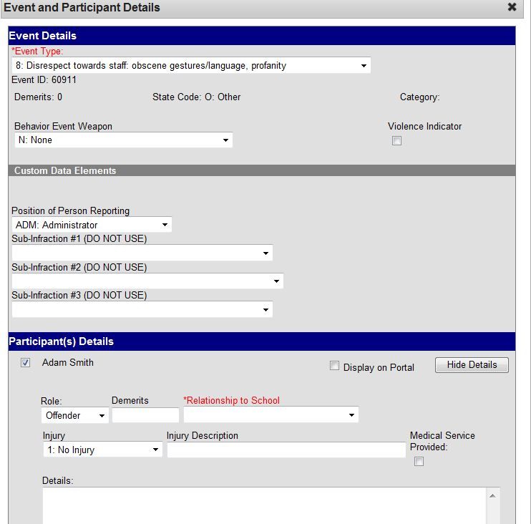

Another event of Throwing Objects was added along with a new participant:

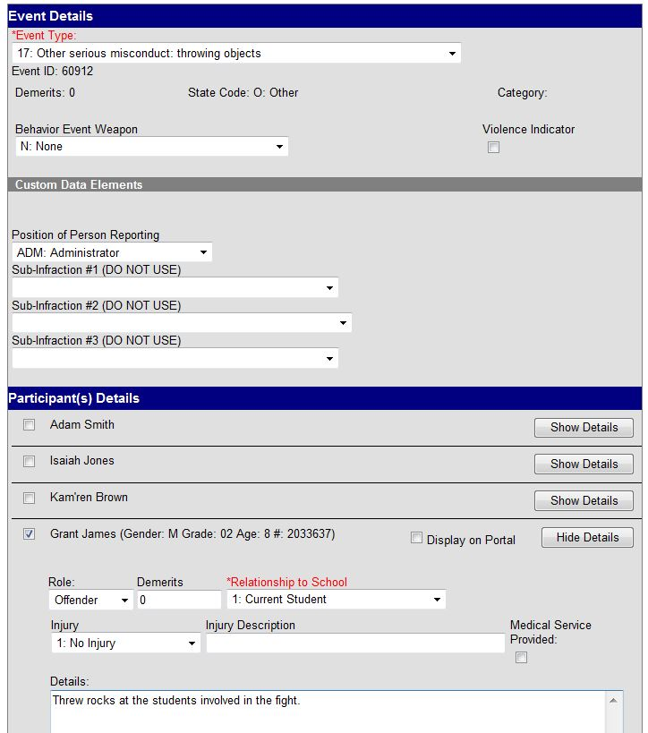

After the Incident, the Events and the Participants are added, Resolutions can be added to those participants that need one.

Adding Resolutions

If the resolution for a student is a Principal’s Suspension, a Superintendent’s Suspension or an Expulsion, the entire Behavior Incident will be entered by Christy DeWees. If the school enters the Behavior Incident because there are other students involved that do not receive a Principal’s Suspension, a Superintendent’s Suspension, or an Expulsion, then please communicate to Christy that you have already entered this Behavior Incident so they can refer to it for the suspended students.

If the resolution is in-school suspension, after school detention, or another minor resolution, these can be entered by someone at your school.

If the resolution is part OSS and part ISS or detention, the Behavior Incident will all be entered by Christy.

To add a resolution, click the “Add Resolution” button under Events and Participants:

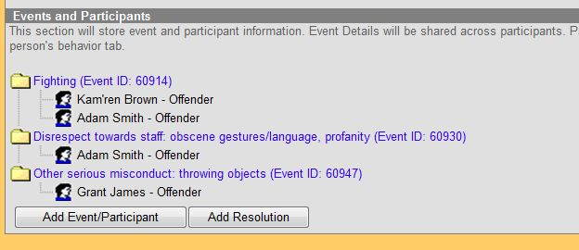

The following screen will appear (shown on next two pages):

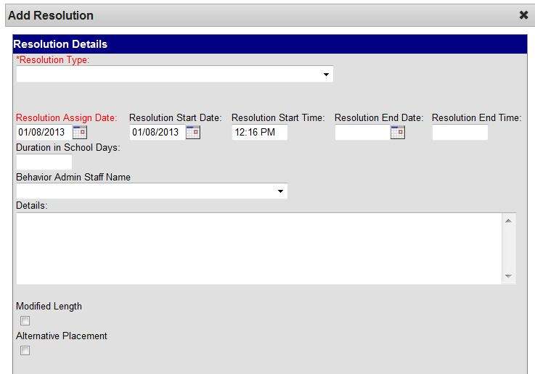

Resolution Type: The identifying name and code of the resolution, sorted alphabetically by name.
Resolution Assign Date: The date the resolution was assigned.
Resolution Start Date: The date the student will begin serving the resolution.
Resolution Start Time: The time the student will begin serving the resolution.
Resolution End Date: The date the student must complete the resolution by.
Resolution End Time: The time the student must complete the resolution by.
Duration is School Days: The length of days the resolution of Suspension or Expulsion will last.
MUST BE A WHOLE NUMBER. DO NOT ENTER (.5)
Behavior Admin Staff Name: The behavior staff member responsible for the resolution.
Details: Additional information about the participant's resolution.
Modified Length: Do not use at this time.
Alternative Placement: Do not use at this time.
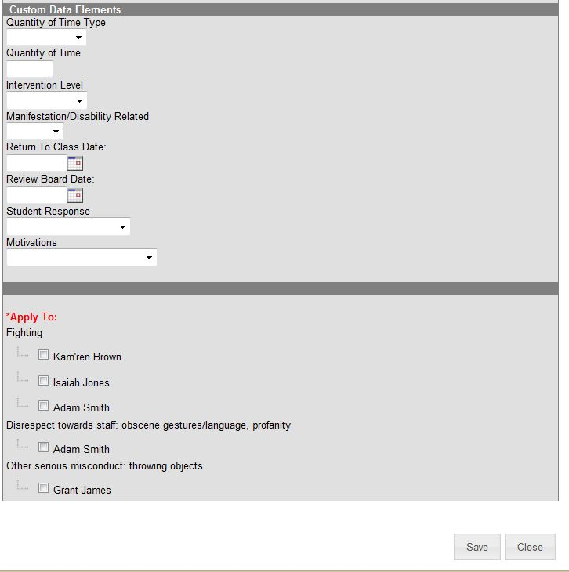

Parkway’s Custom Data Elements:
Quantity of Time Type: D for days or P for Periods
Quantity of Time: Enter the number of days or periods MUST BE A WHOLE NUMBER. DO NOT ENTER (.5)
Intervention Level: 0 for Notice, 1 for Probation, 2 for Warning (to be entered by Christy)
Manifestation/Disability Related: Yes or No (to be entered by Christy)
Return to Class Date: (to be entered by Christy)
Review Board Date: (to be entered by Christy)
Student Response: Admin, Deny, No Response (to be entered by Christy)
Motivations: various codes (to be entered by Christy)

Once a resolution is entered, it can be applied to the appropriate participant by checking the box next to their name.

It’s possible that a student could get one resolution for more than one event they are involved in.
For example, Adam Smith could get a resolution for both the Fighting and the Disrespect Towards Staff events. If you try to assign the same resolution to both events, you get a warning error as seen below. If you do not want to give separate resolutions to this student for both events, just assign the resolution to the most severe event.

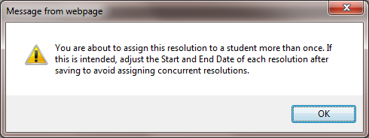

Once all the data for the Incident, Events, Participants and Resolutions have been entered, the Behavior Incident can be marked “Complete”.

